www.artnc.org

Women’s Lives in American Paintings

Writer: Sarah Russell, Social Studies Teacher
Grade Level: 9–12
Related Big Picture Concepts: Identity, Power
Subject Areas: American History, Social Studies, Visual Arts
Essential Question: How have women been portrayed by American artists in the past?

Abstract: Students will examine paintings of American women and deconstruct the details in each piece to explain how women’s status and roles were defined between the late 18th and the early 20th century.

Duration: 1 class period

Focus Works of Art:
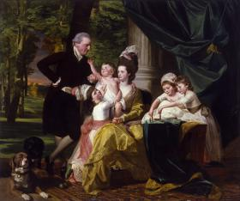
John Singleton Copley (American, 1738-1815)
Sir William Pepperrell (1746-1816) and His Family, 1778
Oil on canvas
90 x 108 in. (228.6 x 274.3 cm)
www.artnc.org/node/293

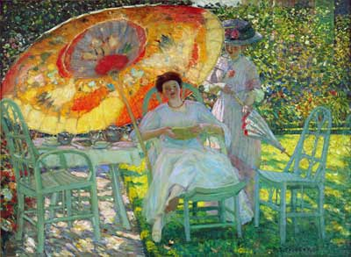
Frederick Carl Frieseke (American, 1874 - 1939)
The Garden Parasol, 1910
Oil on canvas
4ft 9in x 6ft 4in (1m 44.8cm x 1m 93cm)
www.artnc.org/node/313

North Carolina Standards Correlations:
Visual Arts: I.V.1.4, 1.CX.1.1, P.CX.1.1, I.CX.2.3, A.V.2.3
United States History: USH. H.1.2.4, USH.H.4.4
Student Learning Objectives:
- Students will analyze American art as a means of understanding women’s roles in American society within an historical context.
- Students will use their understanding to create an illustration with symbols and elements that are representative of women’s roles in American history.

Activities:
Provide each student with a copy of the Image Analysis Chart. Assign the class to examine Sir William Pepperrell and His Family, The Garden Parasol, and Sunday, Women Drying Their Hair. Ask students to record their observations on the Image Analysis Chart.

- Allowing students to look at their Image Analysis Charts, hold a class discussion focused on the following questions:
  - Who are the women in each of these paintings?
  - Are they rich? How do you know?
  - Are they married or single? How do you know?
  - What deductions can you make about how women were viewed in the American past? (from the late 18th to the early 20th century)

- Assign each student to think of a woman they believe to be of significance in American History. Have them research the impact the woman made on her society and the conditions in which she lived.

- Assign each student to create a portrait of that woman using any materials. Encourage students to choose details that accurately reflect the woman’s identity, status, and impact, including setting, clothing, props, and activities.

- Encourage students to display their portraits and explain how their illustrations reflect their subjects’ status and role in American society.

Assessments:
- Successful completion of the Image Analysis Chart will demonstrate students’ ability to analyze and deconstruct artistic images.
- Active participation in class discussion will demonstrate students’ ability to use artistic analysis as a means to understand social and economic structures within the context of American history.
- Completion of an illustration of a significant American woman, including elements that reveal her role and status, will demonstrate students’ ability to explore a concept creatively through artwork.
- The teacher may use an art rubric to assess each student's illustration.

Resources:
Vocabulary:
composition
identity
mood
portrait
portrayal
setting
status
subject

Materials:
colored pencils, markers, paper

Links:

John Sloan, Sunday, Women Drying their Hair, 1912
http://xroads.virginia.edu/~MUSEUM/Armory/galleryM/sloan.906.html

Art Rubric: http://www.goshen.edu/art/ed/rubric2.html

Image Analysis Chart

Painting  (Title, artist, date) | Composition | Setting | Description of Subject(s) | Action(s) Represented | Mood  (Happy, Sad, Other AND Why) | Predictions

